Comparative Study of Random Forest and XGBoost for Concurrent Flight Prediction Using Operational and Environmental Features

NICHOLAS SINCLAIR ALFIANTO  2702208581  Computer Science  Bina Nusantara University  Jakarta, Indonesia  nicholas.alfianto@binus.ac.id | PAZELLA MUTIA REFLIN  2702343523  Computer Science  Bina Nusantara University  Jakarta, Indonesia  pazella.reflin@binus.ac.id | LAVINIA NATANIELA NOVYANDI  2702331763  Computer Science  Bina Nusantara University  Jakarta, Indonesia  lavinia.novyandi@binus.ac.id
PUTRI MAHARANI SETIAWAN  2702375866  Computer Science  Bina Nusantara University  Jakarta, Indonesia  putri.setiawan002@binus.ac.id | NATASHA DIAN MAHARDITA  2702320210  Computer Science  Bina Nusantara University  Jakarta, Indonesia  natasha.mahardita@binus.ac.id | VANESSA NAYLA PUTRI  2702235084  Computer Science  Bina Nusantara University  Jakarta, Indonesia  vanessa.putri003@binus.ac.id
SYAUQINA ZHAFIRAH NUR FAKHRANA
2702360750
Computer Science
Bina Nusantara University
Jakarta, Indonesia
syauqina.fakhrana@binus.ac.id

Abstract—Accurate prediction of concurrent flight departures is a critical component in managing airport congestion, optimizing ground operations, and preventing delays. This study proposes machine learning models with different configurations to estimate the number of concurrent departures at an airport during a specific time block. Using a rich dataset obtained from Kaggle, which includes temporal, operational, and environmental features, two ensemble-based models Random Forest and XGBoost were developed and evaluated. The models were trained under both default and hyperparameter-tuned configurations, with performance measured using R² score, ean Absolute Error (MAE), and Root Mean Squared Error (RMSE). Experimental results show that the tuned XGBoost model achieved the best performance with an R² of 86.73% on the test set, significantly outperforming its default configuration. Feature importance analysis revealed that airport-level traffic metrics and time-of-day categories were key predictors of concurrent flight activity. To facilitate real-world usability, the final model was deployed through a Streamlit-based dashboard, enabling real-time predictions with a user-friendly interface. This end-to-end system demonstrates the potential of supervised learning in supporting data-driven decisions for airport capacity planning and airline operations.
Keywords—Concurrent flight prediction, XGBoost, Random Forest, hyperparameter tuning, regression model, feature importance, Streamlit, airport congestion, flight scheduling, ensemble learning.
I. INTRODUCTION
Due to the continued growth in both the volume of passengers and the operational complexity of air travel worldwide, the aviation industry is facing increasingly multifaceted challenges. These challenges include ensuring the safety of aircraft operations, minimizing flight delays, maintaining punctuality, and optimizing the allocation of limited resources such as runways, gates, air traffic controllers, and ground crew. As air traffic continues to intensify driven by globalization, urbanization, and the democratization of air travel through low-cost carriers the task of managing airspace and airport infrastructure becomes progressively more demanding. In this context, one of the most fundamental and operationally relevant metrics used to measure and manage this complexity is the count of concurrent flights. This metric refers to the total number of aircraft that are either in the air or actively utilizing airport facilities (such as taxiways, runways, or gates) within a specific time window. Accurately tracking and predicting concurrent flights is crucial because high concurrency can lead to traffic bottlenecks, increased risk of delays or airspace conflicts, and overloads in air traffic control systems, all of which can compromise safety and reduce overall efficiency across the aviation network [1].
Being able to accurately forecast concurrent flight levels is important for proactive airport operations in covering activities like runway scheduling, personnel deployment, and air traffic control planning. Reliable and timely predictions also enable strategies to ease congestion and curb delays, also enhancing passenger experience and operational performance [2]. Furthermore, many traditional statistical forecasting methods such as linear regression, autoregressive models, or time series smoothing techniques often struggle to deliver accurate and reliable predictions when confronted with the inherently non-linear, high-dimensional, and dynamic characteristics of modern flight operations. This limitation becomes especially evident under conditions of operational volatility, such as rapidly changing weather patterns, unanticipated air traffic surges, airport disruptions, or emergency rerouting scenarios. These methods are typically designed under the assumption of linear relationships and stationarity, making them poorly equipped to capture the complex interactions among temporal, operational, and environmental variables that collectively influence flight scheduling and congestion patterns. As a result, they frequently fail to adapt in real-time or provide robust predictions in the presence of sudden fluctuations in flight volume, unexpected system shocks, or contextual anomalies that are common in real-world aviation environments. This performance gap highlights the need for more sophisticated, data-driven approaches capable of modeling non-linear dependencies and learning from complex, multi-source aviation datasets to support proactive and adaptive air traffic management strategie [3].
The aviation sector is progressively embracing cutting-edge machine learning (ML) algorithms as part of a broader digital transformation aimed at addressing the escalating complexity of air traffic management (ATM) systems. These advanced algorithms are particularly adept at modeling nonlinear relationships and uncovering hidden patterns within high-dimensional, multi-source datasets that traditional analytical approaches often fail to capture. The growing adoption of machine learning is driven by the increasing demand for predictive precision, real-time adaptability, and decision-making support in highly dynamic operational environments. Among the various classes of machine learning techniques, ensemble-based models most notably Random Forest (RF) and Extreme Gradient Boosting (XGBoost) have emerged as particularly effective due to their ability to combine the predictive power of multiple learners while mitigating overfitting and improving generalization. These models have demonstrated strong performance across a wide spectrum of aviation applications, including delay prediction, demand forecasting, runway occupancy estimation, and traffic flow optimization. Their capacity to handle complex feature interactions and imbalanced datasets makes them suitable for deployment in mission-critical scenarios where reliability and accuracy are paramount. As a prominent illustration of the growing value of data-driven methodologies in aviation, supervised learning algorithms such as RF and XGBoost have been successfully applied to predict and support the implementation of Air Traffic Management (ATM) initiatives, enabling more proactive planning, enhanced situational awareness, and improved operational resilience in the face of fluctuating traffic volumes and environmental uncertainties [1].
With a forecasting accuracy of approximately 80% for delays exceeding 15 minutes, Extreme Gradient Boosting (XGBoost) has consistently demonstrated superior performance in flight delay prediction tasks when compared to traditional statistical or rule-based models. This level of accuracy is particularly noteworthy in the aviation domain, where prediction errors can have substantial operational, financial, and safety consequences. XGBoost's effectiveness stems from its gradient boosting framework, which sequentially refines weak learners to minimize prediction errors, enabling it to capture complex nonlinear interactions among numerous operational, temporal, and environmental features commonly found in large-scale flight datasets [2]. The predictive power of flight delay models developed using large-scale aviation datasets has also experienced significant enhancement through the adoption of ensemble-based machine learning models, particularly when integrated into hybrid predictive frameworks. These hybrid architectures typically combine the strengths of various computational techniques—such as time-series forecasting, environmental feature engineering, spatial-temporal correlation analysis, and deep learning components—with ensemble methods like Random Forest or XGBoost. By doing so, they are better equipped to model the highly dynamic and interdependent nature of aviation operations [4]. These results demonstrate the adaptability and resilience of ensemble learning in handling the complex problems of contemporary air transportation networks.
In this paper we will discuss a head‑to‑head comparison of RF and XGBoost for predicting concurrent flight counts, using a dataset of over six million flight records. The feature set incorporates temporal indicators (e.g., departure time blocks, day of week), operational details (e.g., aircraft age), and environmental factors (e.g., temperature, precipitation), along with historical delay metrics at both the airline and airport levels. The primary contributions of this work are:
- A comparison of RF and XGBoost for concurrent flight volume prediction.
- A detailed evaluation of each models accuracy, error metrics (R², MAE, RMSE), and feature importance.
- Practical guidance on the trade‑offs and deployment considerations when implementing these ensemble models in real‑time “smart” airport systems.
By elucidating the relative advantages and limitations of these ensemble regressors, this study aims to inform an adaptive, data‑driven air traffic management solutions.

2. LITERATURE REVIEW
2.1.Air Traffic and the Need for Concurrent Flight Prediction
Global air travel volume has consistently shown a discernible upward trend throughout time. The primary forces behind this growth are the expansion of the global economy, advancements in aviation technology and infrastructure, and the rising demand for air travel [5], [6].During the COVID-19 epidemic, the aviation industry's resilience was further demonstrated, especially in Europe. Even though air travel fell precipitously during the worst of the crisis, the industry recovered well after restrictions were removed, demonstrating its structural resilience and vital role in promoting global mobility and economic integration. Airport networks' flexibility and smart policy responses were crucial in stabilizing operations and restoring passenger confidence in the post-pandemic era, as demonstrated by Burbano, Gillen, and Morrison (2024)[7].
Furthermore, even though the COVID-19 pandemic originally caused a sharp drop in passenger volume, it resulted in a renewed emphasis on adaptive aviation tactics. Following the epidemic, passenger demand quickly recovered in both European and Asian markets, particularly in areas where preemptive investments in digital air traffic management and airport renovation were made. These trends imply that greater reliance on international mobility, urbanization, and socioeconomic recovery will all likely contribute to future increases in air traffic volumes. Predicting, controlling, and optimizing increasing flight volumesparticularly concurrent air operations has thus emerged as a key challenge in contemporary aviation planning.
Concurrent flights, in which many flights operate simultaneously inside the same airspace or airport zone, are becoming more likely, according to this trend. Concurrent flights that are poorly handled can have a detrimental effect on airport operations and the effectiveness of the air navigation system. Air traffic controllers may experience delays, airspace congestion, and an increase in workload as a result of such circumstances [8]. In the journal Mathematics (2023), Yang et al. emphasized that the increasing demand for air travel and worldwide mobility lead to an increase in flight volume, which further complicates air traffic control systems [6].
The development of intelligent and adaptive airspace management systems is becoming increasingly reliant on the integration of data-driven predictive techniques within the broader framework of air traffic control (ATC). As the complexity of global aviation networks intensifies driven by increasing flight volumes, denser airspace usage, and dynamic operational constraints the traditional reactive approaches to air traffic management are no longer sufficient to ensure safety, efficiency, and punctuality. In this context, predictive analytics emerges as a critical enabler for transitioning from reactive to proactive traffic management paradigms [9], [10]. Broad-scale aviation indicators including overall traffic demand, the statistical likelihood or probability of delays, as well as the environmental implications such as energy consumption and carbon emissions resulting from increasing aircraft movements can all be predicted with a relatively high degree of accuracy through the application of advanced data-driven methods. These predictive approaches, which often combine machine learning, statistical modeling, and time-series analysis, enable stakeholders to analyze historical trends, detect emerging patterns, and forecast future aviation scenarios under varying operational and environmental conditions..
For example, Emami Javanmard et al. [9] investigated the relationship between environmental consequences and demand forecasts for air transportation, highlighting the strategic use of predictive analytics in long-term planning. Similar to this, Verma et al. [10] After conducting a comprehensive review of more than 160 recent studies in the domain of Air Traffic Flow Management (ATFM), researchers have identified a clear and accelerating trend toward the adoption of data-centric optimization models aimed at enhancing traffic scheduling efficiency and mitigating congestion across complex airspace systems. These models leverage advanced computational techniques including machine learning, metaheuristic optimization, and dynamic programming to support predictive, real-time decision-making for balancing air traffic demand with available capacity.
This represents a critical gap, particularly as simultaneous flight volumes in shared airspace pose growing challenges for airport capacity, air traffic controller workload, and system resilience. Most existing models lack the granularity required to forecast how many flights are likely to occur at the same time in a given spatial-temporal window. Bridging this gap by developing accurate and scalable predictive models for concurrent flights can provide substantial operational value and directly support next-generation ATFM strategies.
2.2.Features Affecting Flight Operations
The number of concurrent flights can be predicted based on a number of factors:
2.2.1 Temporal
Season, time of day, and day of the week are examples of transient variables that are part of temporal dynamics, which have a significant impact on flight operations. Airport congestion, flight demand patterns, and the likelihood of delays are all greatly impacted by these temporal factors. For example, departures during peak hours, weekend plans, and seasonal changes like vacation travel times or unfavorable weather seasons introduce predictable variations in traffic volumes and the probability of delays. Zhu et al. [1] showed that the accuracy of flight delay predictions can be improved by combining spatiotemporal information into predictive models with a self-corrective causal inference framework. Their methodology demonstrates how capturing the operational complexity of contemporary aviation systems requires the modeling of time-dependent trends. [11].
2.2.2 Operational
Numerous airline-specific and aircraft-specific factors have a substantial impact on operational performance and the probability of flight delays. These include the age of the aircraft, the model or kind of aircraft being utilized, and the airline's operational procedures. Delays in departure or arrival could be more likely with older airplanes since they may be more prone to technical problems or need more frequent maintenance. Furthermore, under particular operating circumstances, some aircraft models could perform differently or have varying turnaround times. Because variations in fleet management, scheduling effectiveness, and resource allocation can affect on-time performance, the airline operator is also crucial.
In a thorough investigation of international flight delays across European airlines, Zámková et al. [12] found that airline procedures, aircraft type, aircraft capacity, and flight characteristics (such as regular versus charter) were all important factors in delay occurrences. Their results highlight how crucial it is to incorporate operational characteristics into predictive delay models since they provide important information on systemic delay causes that are based on air carriers' operational structures.
2.2.3 Environmental
One important category of characteristics that has a big impact on flight operations and delays is the environment. Both the ground and airborne phases of flight are directly impacted by climate-related factors such precipitation, wind speed, visibility, and ambient temperature. For example, poor visibility or heavy rain can cause delays in taxiing or takeoff, increase separation needs, and decrease runway throughput. In a similar vein, crosswinds, turbulence, and wind shear can disrupt safe landing and departure protocols, impacting controller workload and scheduling dependability.
Zhao et al. [13] emphasize the importance of integrating environmental parameters into predictive models for air traffic delay forecasting. Their study employed advanced machine learning architectures CNN-LSTM and TCN-LSTM optimized through the Sparrow Search Algorithm (SSA) to analyze flight data from four major airports in Eastern China. The inclusion of weather-related features such as wind speed, precipitation, and temperature was shown to improve the accuracy of delay prediction significantly. Specifically, models that included environmental features achieved a reduction in Mean Absolute Error (MAE) by more than 2.5 minutes compared to those that excluded such inputs. These findings underscore the necessity of incorporating environmental variables in any robust predictive system aimed at improving the efficiency and safety of air traffic flow.
2.2.4 Historical Performance
In order to comprehend delay trends and increase forecasting accuracy, historical performance data pertaining to airline operations and airport efficiency is essential. Detailed records of departure and arrival times, cancellation rates, delay times, aircraft turnaround times, and other operational metrics gathered over time are examples of this type of data. Researchers and decision-makers can find seasonal variations, recurrent trends, and bottlenecks unique to a given route that cause delays by examining this longitudinal data, providing a data-driven basis for predictive modeling.
In this regard, Biswas et al. [14] used historical aviation datasets to present a deep feedforward regression model that incorporates spatio-temporal feature engineering to forecast flight arrival delays. The importance of time-sensitive and location-based variables in learning delay behaviors was highlighted by their study, which used delay records spanning several years. High predicted accuracy was attained by the model, proving that deep learning techniques are ideally adapted to capture intricate relationships between operating schedules, historical delay trends, and airport-specific features. This result supports the notion that, when applied to strong machine learning frameworks, historical data is an active predictor of future delay scenarios rather than just a passive record.
Additionally, the utilization of past delay data gives other predictor categories—like operational or environmental features—contextual grounding, allowing models to identify the circumstances that increase the likelihood of delays. Using historical delay dynamics might help the model better identify temporal patterns and anticipate congestion peaks in concurrent flight forecasting scenarios, where several aircraft fly concurrently inside common airspace or terminal zones. In the end, historical performance data is a vital tool for creating air traffic management systems that are more resilient, intelligent, and anticipatory.
2.3.Ensemble Learning Models in Aviation
Ensemble learning, which integrates several base learners to improve forecast accuracy, has become a key technique in aviation research. The large, intricate, and nonlinear nature of aviation data makes ensemble methods like Extreme Gradient Boosting (XGBoost) and Random Forest (RF) especially appropriate. RF provides outstanding interpretability and stability, efficiently recording important features like weather and flight schedules. Meanwhile, because of its excellent computational efficiency and prediction accuracy, XGBoost performs exceptionally well in real-time deployment circumstances. Several studies show that both models perform better than conventional methods in crucial aviation applications such as traffic load estimate and flight delay prediction [2], [15].
To find out which performs better in the context of concurrent flight prediction—the number of flights running simultaneously—a comparison analysis between RF and XGBoost is carried out in this work.
2.3.1 Random Forest (RF)
Random Forest (RF) is an ensemble learning technique that constructs multiple decision trees in parallel using the bagging method. The final output is determined through majority voting in classification tasks or by averaging in regression tasks, which enhances prediction accuracy and mitigates overfitting. RF is particularly suitable for flight delay prediction problems involving diverse features such as weather conditions, flight routes, and schedule frequency. Its capability to process large datasets with high-dimensional attributes and minimal preprocessing makes it ideal for operational aviation analytics. A study demonstrated the effectiveness of Random Forest in modeling flight punctuality by incorporating meteorological factors and flight scheduling data, highlighting its robustness in capturing complex patterns in delay-related datasets [21].
In addition to solid predictive performance, Random Forest (RF) enhances interpretability through feature importance metrics, revealing which variables most influence the prediction outcomes. A study by Ajayi et al. applied RF to predict flight delays across the U.S. airport network and reported an accuracy of up to 86.2% using features such as network centrality and time-of-day indicators, illustrating RF’s usefulness in both technical modeling and operational decision-making contexts [22].
2.3.2 Extreme Gradient Boosting (XGBoost)
Large-scale aviation dataset analysis has shown great success with XGBoost, a boosting-based method that builds decision trees successively to correct the residuals of previous models. Strong handling of high-dimensional data is made possible by its integrated L1 and L2 regularization, and computational performance is greatly increased by its cache-aware, histogram-based split algorithms and native techniques for handling missing values [15].
In a noteworthy study, Kılıç and Sallan [23] used Random Forests, neural networks, and Gradient Boosting Machines (GBM), a forerunner to XGBoost, to forecast arrival flight delays throughout the U.S. airport network. Their findings demonstrated the applicability of ensemble learning frameworks for aviation problems by showing that GBM performed better than other standalone models in forecasting delays using actual flight and meteorological data
In order to predict departure flight timings within the terminal maneuvering areas (TMAs), Wang et al. [15] used a complete ensemble learning strategy that combined bagging, boosting, and stacking techniques. Their model achieved up to 89% accuracy within a 1-minute absolute error by integrating features from initial aircraft states, operational conditions, traffic demand, and wind data. This shows the superior prediction power and real-time potential of ensemble models in departure management systems..
XGBoost's exceptional accuracy and runtime efficiency are widely acknowledged in both manufacturing and aviation applications. Hatıpoğlu & Tosun (2024), for example, applied XGBoost to Turkish airport data and found that the model performed better than others in forecasting delays longer than 15 minutes, with an accuracy of 80%. Furthermore, SHAP interpretation showed that weather and temporal factors had the greatest influence [15]. This demonstrates XGBoost's applicability to challenging concurrent flight prediction challenges.
2.4. Hyperparameter Optimization Techniques
One of the main obstacles in machine learning is choosing and fine-tuning the best parameters for creating accurate and trustworthy predictive models. These parameters can be roughly divided into two categories: hyperparameters, which are specified before training and control the learning process itself, and parameters, which are learned from the data during the training phase. Hyperparameters have a major impact on a model's computing cost, generalization ability, and complexity. As a result, creating high-performance models requires hyperparameter optimization (HPO), particularly for intricate algorithms like Random Forest (RF) and Extreme Gradient Boosting (XGBoost) [16].
Furthermore, the choice of hyperparameter tuning strategy has a significant impact on the precision and effectiveness of machine learning models, especially ensemble approaches like XGBoost. These models run the danger of performing poorly because of less-than-ideal configurations in the absence of a suitable optimization procedure, which could jeopardize their ability to predict outcomes in intricate datasets. Although conventional methods like Grid Search and Randomized Search have been extensively used, more advanced alternatives have been investigated in recent research. For example, it has been demonstrated that a modified Bayesian optimization framework greatly improves XGBoost's performance by effectively navigating the hyperparameter space and lowering the computing cost related to exhaustive search techniques. This method provides a more flexible and data-efficient strategy to find the best model settings, particularly for prediction tasks involving aviation [17].
2.4.1 Grid Search (GridSearchCV)
Grid Search is a brute-force optimization technique that takes into account every possible combination of predefined hyperparameter values in order to determine the ideal configuration. Despite being computationally demanding, Grid Search is very useful in fields like aviation where model stability and dependability are crucial since it can locate the global optimum inside the search space. Complex models like Random Forest (RF) and Extreme Gradient Boosting (XGBoost), which frequently need fine-grained calibration to function well on heterogeneous datasets, can be systematically tuned with this technique. Grid Search has been demonstrated to improve model robustness in aviation applications, where even minor increases in forecast accuracy can have a big practical impact. A structured feature space formed from review sentiments and service ratings was used by Xu et al. [18] to support this claim by applying machine learning models to predict airline passenger pleasure. Their research showed that meticulously tuned models greatly enhance prediction performance, highlighting the usefulness of fine-tuning techniques like Grid Search in aviation-related activities.
Darmawan, Yuliana, and Hadi (2023) demonstrated the efficacy of systematic hyperparameter tweaking by assessing the performance of GRU and XGBoost models within an Internet of Things-based weather prediction system using GridSearchCV. Their results showed that using GridSearchCV greatly improved the models' accuracy and resilience, especially when working with intricate sensor-based environmental information. The study demonstrated the usefulness of thorough tuning techniques by showing that models with fine-tuned configurations outperformed those with default configurations in terms of generalization and interpretability. These results are particularly pertinent to aviation-related tasks like flight delay prediction and air traffic management, which frequently face comparable difficulties—namely, temporal dependencies, non-linear interactions between variables, and multi-source data integration. This highlights how important it is to optimize hyperparameters precisely in order to find trustworthy predicting patterns in operationally varied datasets [19].
2.4.2 Randomized Search (RandomizedSearchCV)
As an alternative to Grid Search, Randomized Search provides a more computationally efficient approach to hyperparameter optimization, particularly in scenarios involving large and complex search spaces. Rather than evaluating every possible combination of hyperparameters, as in exhaustive grid search, RandomizedSearchCV samples a fixed number of parameter settings from a specified distribution. This allows it to explore a broader portion of the hyperparameter space in significantly less time, often uncovering high-performing configurations with minimal computational cost [32].
The core advantage of Randomized Search lies in its balance between optimization quality and computational feasibility. While it does not guarantee the discovery of the absolute best hyperparameter set, empirical studies have shown that it is often able to reach near-optimal solutions with far fewer iterations than grid-based methods making it a compelling option in practical machine learning pipelines [32]. This trade-off is particularly valuable when working with high-dimensional datasets such as those used in concurrent flight prediction, where model iteration speed is crucial due to time and hardware constraints.
The effectiveness of RandomizedSearchCV has been demonstrated across numerous domains, including spatial and environmental modeling. For example, a study by Kavzoglu and Teke [20] highlighted its impact on improving predictive accuracy in a spatial modeling task involving XGBoost for shallow landslide susceptibility mapping. Their results showed that Randomized Search successfully managed complex non-linear relationships between spatial features, achieving competitive accuracy while reducing computational burden. This outcome confirms that RandomizedSearchCV is not only an efficient tuning method, but also scalable and adaptable, making it especially suitable for ensemble models like Random Forest and XGBoost when applied to air traffic forecasting problems, which often involve limited processing resources and heterogeneous, high-dimensional features.
Overall, the adoption of Randomized Search in this study was driven by the need to find a practical and scalable hyperparameter optimization strategy. By leveraging the computational efficiency of randomized sampling, the tuning process was able to yield improved model performance without incurring prohibitive training costs. This method's alignment with real-world constraints reinforces its relevance for operational use cases in aviation and other time-sensitive predictive systems.
2.4.3 Importance in RF vs. XGBoost Comparative Study
In order to ensure a fair and scientifically valid comparison between RF and XGBoost for concurrent flight prediction, hyperparameter adjustment becomes essential. The learning dynamics and predictive capacity of both models are significantly influenced by a number of adjustable factors, including the number of trees, learning rate, maximum depth, and subsampling rates. Inadequate tuning of these factors could lead to biased assessments that give preference to one model over another for non-model-related reasons.
Additionally, adjusting reveals which model works better as well as the data contexts and settings in which it thrives. In the aviation industry, where several models may react differently to environmental or temporal factors, this detailed insight is very helpful. Consistent and well-structured hyperparameter optimization is crucial for any comparative machine learning research to prevent false results, according to a recent benchmarking study by Bischl et al. (2021) [16].
This study guarantees that the comparison between RF and XGBoost is based on methodological rigor and fairness by include both Grid Search and Randomized Search in the tuning procedure. The outcomes of these refinements will improve the predictive framework's reproducibility and usefulness in actual aviation settings in addition to guiding model selection.
2.5. Previous Studies and Comparative Evaluations
In predicting flight delays, several studies that directly compared Random Forest with XGBoost. The results show that XGBoost frequently achieves greater accuracy and robustness, especially when working with complicated and unbalanced aviation data.
A study by researchers Hatıpoğlu and Tosun (2024) used many algorithms, including RF and XGBoost, to anticipate delays longer than fifteen minutes at a Turkish airport. According to their findings, XGBoost outperformed RF, Neural Networks, Logistic Regression, Naïve Bayes, and CatBoost in terms of classification performance, achieving an accuracy of 80%. In order to enhance the model, they additionally added weather features and addressed class imbalance using SMOTE [15]. This study demonstrates that XGBoost performs exceptionally well when dealing with real-world, unbalanced datasets that have a variety of features, which is a typical situation in the aviation industry.
Another large-scale study by Ajayi et al. that looked at the use of aerial traffic data and network centrality to improve delay prediction showed similar findings. Their results demonstrated the effectiveness of tree-based ensembles, such as RF, Gradient Boosting, and CatBoost, in capturing intricate temporal and operational patterns. But once more, XGBoost showed the best prediction performance, especially when paired with sophisticated feature engineering like centrality metrics [24].
Furthermore, XGBoost produced the best mean accuracy (>95%) across both PCA and feature-selection-reduced datasets, according to Afrane et al.'s (2025) comparison of RF, XGBoost, and $k$-nearest neighbor models on a Kaggle dataset [25]. This demonstrates even further how XGBoost may use dimensionality reduction while still having a strong prediction power.
Experimental results demonstrate that XGBoost tends to perform better in accuracy than RF, especially in complicated, feature-rich domains, even though RF is a reliable, interpretable baseline model. Because these tasks have comparable data complexities and operational subtleties, our study analyzes both models not just on delay prediction tasks but also on forecasting the number of concurrent flights.
2.6.Research Gap and Contribution
Due to its immediate operational, financial, and customer service ramifications for airlines, airports, and passengers, flight delay prediction has emerged as a key area of study in machine learning linked to aviation. Large volumes of structured and semi-structured data are produced as aircraft operations become more digitally integrated, calling for strong analytical techniques. For handling the complexity and volume of such data, ensemble learning methods like Random Forest (RF) and Extreme Gradient Boosting (XGBoost) have proven to be quite successful.
Demir et al.'s thorough analysis of AI applications in aviation safety [26] emphasizes the expanding use of ensemble learning models in crucial areas such operational risk assessment, delay prediction, and air traffic control optimization. According to their investigation, algorithms such as Random Forest (RF) and XGBoost perform better than conventional statistical techniques and are especially good at handling the non-linear interactions among various flight-related parameters. These models are useful instruments for improving decision support and forecast accuracy in air operations since they have shown great promise in managing intricate, multifaceted aviation datasets.
In a related study, Dai [4] presented a hybrid model for large-scale flight delay prediction using aviation big data that combines weighted Random Forest and XGBoost. The model outperformed traditional ML techniques with an accuracy of around 97%. When used on high-dimensional aircraft datasets, the study emphasizes the flexibility and scalability of ensemble-based approaches.
The literature still mostly focuses on general delay forecasting or overall traffic estimation, despite these encouraging developments. There is still much to learn about the particular issue of concurrent flight prediction, which is the forecasting of the number of flights flying concurrently within a specific airspace or terminal zone. For the development of systems that can improve operating capacity and situational awareness in increasingly crowded airspace settings, closing this research gap is essential.
The capacity to precisely predict concurrent flights is essential for efficient ground operations scheduling, airport throughput optimization, and the management of controller workload and airspace congestion in the context of real-time air traffic management. While general traffic forecasting and flight delay prediction have been the subject of several studies, the challenge of concurrent flight prediction—that is, estimating the number of aircraft operating concurrently within shared airspace or airport regions—has received very little attention.
In their thorough analysis of more than 160 papers in the field of air traffic flow management (ATFM), Verma et al. [10] emphasized the growing significance of machine learning-based techniques in addressing demand-capacity mismatches. However, modeling overlapping flights in time and space receives little attention in the reviewed literature, which mostly concentrates on aggregate delay or larger traffic flow control models. Given the growing traffic levels and the operational burden they inflict on crowded airports, this gap offers a substantial research opportunity.
The current study suggests a machine learning-based framework for concurrent flight prediction employing ensemble learning techniques like Random Forest and XGBoost in order to overcome this restriction. The suggested method prioritizes simultaneous traffic estimation at the temporal and spatial levels, in contrast to traditional delay models. It is anticipated that this contribution would promote more responsive and effective traffic flow planning and improve situational awareness in air traffic operations.
Furthermore, few studies combine a thorough set of operational, environmental, and temporal features into a single predictive model, whereas many focus on weather-based or temporal features. In order to close that gap, this study uses two potent ensemble learning algorithms—Random Forest and XGBoost—to create a prediction model for concurrent flights. A strong framework for simulating actual aviation conditions is provided by the dataset utilized in this study, which consists of millions of flight records and covers a wide range of parameters such departure time, aircraft age, airline, weather, and history delay performance.
The following are the research's primary contributions:
- Comparatively assessing two ensemble models used for the less-studied concurrent flight prediction challenge.
- Examining the significance of characteristics in relation to flight volume across operational, environmental, and temporal categories.
- Providing a basis for the development of data-driven smart airport systems, which depend on precise forecasts to facilitate effective ground and air traffic decision-making.
As a result, this research not only broadens the focus of previous studies but also offers useful insights that facilitate strategic decision-making within the framework of contemporary aviation management.

3. RESEARCH METHODOLOGY
The core objective of this research is to develop a machine learning system capable of predicting the number of concurrent flights departing from an airport during a given departure block. This variable is a representation for congestion, which can influence delays, resource utilization, and flight scheduling efficiency.
The research methodology uses six main stages approaches which are data acquisition from public sources, data preprocessing and transformation, model selection and implementation, hyperparameter tuning for optimization, model evaluation using statistical and visual metrics, model persistence and deployment through a web-based interface. Two ensemble regression algorithms such as Random Forest and XGBoost were used based on their proven effectiveness in doing tasks with structured data involving high-dimensional features and complex interactions [27].
A. Data Collection and Overview
The dataset used in this study was obtained from Kaggle and contains historical flight data augmented with operational, environmental, and aircraft-specific attributes. Each row corresponds to a flight departure event, and the goal is to predict how many other flights are scheduled to depart from the same airport in the same departure time block, captured in the variable CONCURRENT_FLIGHTS. Furthermore, the dataset includes 27 features that influence concurrent flight volume, grouped into the following categories:
Temporal Variables:
- Month: Represents the calendar month (1–12).
- DAY_OF_WEEK: Numerical encoding of the day (1 for Monday to 7 for Sunday).
- DEP_TIME_BLK: Categorical descriptor of departure time intervals (e.g., "0600-0659").
Flight and Aircraft Characteristics:
- DISTANCE_GROUP: Grouped flight distance bands.
- SEGMENT_NUMBER: Identifies the flight’s order for the aircraft that day.
- NUMBER_OF_SEATS: Total seats available on the aircraft.
- PLANE_AGE: Estimated age of the aircraft in years.
Airline and Airport Operational Metrics:
- AIRPORT_FLIGHTS_MONTH: Average monthly departures from the airport.
- AIRLINE_FLIGHTS_MONTH: Average monthly departures for the airline.
- AIRLINE_AIRPORT_FLIGHTS_MONTH: Monthly departures for the airline-airport combination.
- AVG_MONTHLY_PASS_AIRLINE: Average monthly airline passengers.
- FLT_ATTENDANTS_PER_PASS: Ratio of flight attendants per passenger.
- GROUND_SERV_PER_PASS: Ratio of ground crew per passenger.
Weather Data:
- TMAX: Daily maximum temperature.
- AWND: Maximum sustained wind speed.
Target Variable:
- CONCURRENT_FLIGHTS: A continuous value denoting the number of other flights scheduled in the same departure window from the same airport.
Some features were removed during preprocessing, including DEPARTING_AIRPORT, PREVIOUS_AIRPORT, CARRIER_NAME, LATITUDE, LONGITUDE, PRCP, SNOW, SNWD, AWND, and AVG_MONTHLY_PASS_AIRPORT. These features were excluded due to high cardinality, redundancy, or limited predictive relevance.
B. Data Preprocessing

In order to make the machine learning models perform well, we need to do preprocessing. Implementing an effective preprocessing is essential in order to produce reliable machine learning models [28], so we do this following steps below:
- Remove Missing Value
All rows with missing values were removed from the dataset to preserve data consistency. Missing value rows can influence model performance because it is set to be NULL
- Categorical Feature Engineering
The DEP_TIME_BLK column, which originally used hourly intervals, was reclassified into more intuitive time-of-day categories:
- Subuh (00:00–05:59)
- Pagi (06:00–11:59)
- Siang (12:00–17:59)
- Sore (18:00–21:59)
- Malam (22:00–23:59)
These were then transformed into binary variables using one-hot encoding.
- Sampling for Computational Efficiency
To prevent memory overload, especially during hyperparameter tuning, the dataset was sampled into 1.5 million to 2 million data rows.
- Train-Test Split
The dataset was split into training and testing sets using a 70:30 ratio. Stratified sampling was not required as the target variable is continuous. The split ensured that both sets had comparable statistical distributions.
- Normalization
While tree-based models like Random Forest and XGBoost are insensitive to feature scaling, normalization was reviewed but not applied, as it would not benefit model performance or stability in this context.
C. Model Selection
This study employs two supervised machine learning algorithms which are Random Forest Regressor (RF) and Extreme Gradient Boosting (XGBoost) to predict the number of concurrent departing flights. These models were chosen due to their high predictive accuracy on structured datasets, their ability to capture nonlinear interactions, and their durability to feature redundancy [27].
- Random Forest Regressor (RF)
Random Forest builds an ensemble of decision trees by bootstrapping training samples and aggregating predictions through averaging. It provides robust performance and intrinsic feature importance estimation [29]. RF for this task because RF has high tolerance for multicollinearity, which is useful given the presence of correlated airline and airport operational features. Built-in handling of non-linear feature interactions, which are expected in flight related scheduling data. Intrinsic feature ranking capabilities, which assist in interpreting important variables after training [29].
Baseline Hyperparameters were defined conservatively to allow deep, unconstrained trees for initial learning:
Table 1. Default Random Forest Parameter
Parameter | Value
n_estimators | 100
max_depth | none
min_samples_split | 10
min_samples_leaf | 5
random_state | 42
n_jobs | -1 (parallel execution)
To avoid exhaustive search across all possible parameter combinations (which would be computationally expensive), RandomizedSearchCV was employed. This method samples from the parameter grid stochastically, offering a trade-off between performance and computational cost.
Table 2. RandomizedSearchCV Hyperparameter
Parameter | Value
n_estimators | 100, 300, 500
max_depth | None, 20, 30, 40
min_samples_split | 2, 5, 10
min_samples_leaf | 1, 2, 4, 8
max_features | sqrt, log2
bootstrap | True / False
Each combination was validated using 2-fold cross-validation due to the dataset's large size. The model with the best R² score on validation data was selected for final training.
- XGBoost Regressor
XGBoost is a gradient boosting framework that iteratively adds weak learners to minimize the residual error. Unlike Random Forest, it builds trees sequentially, allowing for highly flexible function approximation [30]. This model was chosen to do this task because it offers fine-grained control over model complexity through parameters like gamma, min_child_weight, and regularization terms. It includes L1/L2 regularization to mitigate overfitting, which is particularly important in high-dimensional spaces [30]. It efficiently handles large datasets through parallel processing, well-suited to the large 6.5 million row dataset.
Baseline Configuration:
Table 3. Default XGBoost Parameter
Parameter | Value
n_estimators | 100
learning_rate | 0.1
max_depth | 6
subsample | 0.8
colsample_bytree | 0.8
random_state | 42
n_jobs | -1 (parallel execution)
A stepwise GridSearchCV was implemented in four stages to iteratively refine the most sensitive parameters:
Table 4. XGBoost Parameters Explanation
Step | Parameters | Notes
1 | max_depth, min_child_weight | Controls model complexity and leaf weight
2 | subsample, colsample_bytree | Influences data and feature randomness
3 | learning_rate, n_estimators | Balances bias and variance trade-off
4 | gamma | Prunes unhelpful splits to control overfitting
Two-fold cross-validation was used in all steps for feasibility. After tuning, the final model was retrained on the full training data using the best parameters.
D. Evaluation Strategy
To evaluate the models in a consistent and informative way, a combination of metrics was selected to reflect both general accuracy and robustness to extreme errors:
Table 5. Evaluation Metrics Justification
Metric | Justification
R² (Coefficient of Determination) | Reflects the proportion of target variance explained by the model. Useful for comparing training vs test performance.
Mean Absolute Error (MAE) | Measures average prediction error in the same unit as the target, making it intuitive to interpret.
Root Mean Squared Error (RMSE) | Penalizes larger errors more than MAE, highlighting variance-sensitive prediction issues.
These metrics were applied to both training and test sets to monitor overfitting and ensure model generalization. All evaluations were carried out using standard scikit-learn metric functions.
E. Model Persistent & Deployment
To avoid retraining the model each time, both final models were serialized using the pickle module. The saved .pkl files store the full model objects, including preprocessing steps, hyperparameters, and learned patterns. This facilitates repeatable inference and easy transfer across systems.
A user-friendly web interface will be created using Streamlit, aimed at supporting real-time, interactive usage by non-technical stakeholders such as airline schedulers or airport ground operations. The deployed app includes:
- Input Interface: Users can input new flight data for prediction.
- Prediction Output Viewer: Displays predicted concurrent flights in real-time.
- Basic Visualization Tools: Including bar plots of predicted values and top contributing features.
This interface serves as a prototype for operational integration, allowing business users to test the model’s utility in live planning scenarios. Deployment was conducted locally but can be hosted on cloud platforms such as Streamlit Cloud or Heroku for broader accessibility.
F. Exploratory Data Visualization
Before proceeding with modeling, exploratory data analysis (EDA) was conducted using tools Power BI to understand the structure and distribution of the dataset. Power BI was chosen for its rich interactive visualization capabilities, which allowed for a comprehensive review of key features and trends.The following key components were developed:
- KPI Cards
Displayed aggregate metrics such as:
- Total concurrent flights
- Total seats booked
- Average plane age
- Percentage of delayed flights
- Average max temperature
- Time Series Charts
Monthly trend of concurrent flights
- Average concurrent flights per month
- Average concurrent flights per day of the week
- Category Based Visual
- Pie charts of flight distributions by DEP_TIME_BLK and DAY_OF_WEEK
- Histogram
- Frequency distribution of CONCURRENT_FLIGHTS to assess skewness
- Tabular View
- Aggregated concurrent flight counts, seats sold, and monthly airport traffic by departing airport
These exploratory visuals played a critical role in
- Identifying dominant patterns and outliers
- Confirming the importance of temporal variables like DAY_OF_WEEK and DEP_TIME_BLK
- Justifying the need for grouping and encoding certain features
- Informing the sampling strategy and transformation decisions used later in preprocessing
No model-related outputs or predictions were visualized at this stage Power BI served strictly as a tool for initial data profiling and feature evaluation.
G. Technical Setup
All experiments and deployments were conducted in the following environment:
Table 6. Technical Component Specification
Component | Specification
Programming Language | Python 3.10
IDE & Notebooks | Jupyter Notebook, VSCode
Libraries | Scikit-learn, XGBoost, Pandas, NumPy, Seaborn, Matplotlib, Streamlit
Dataset Size | ~6.5 million rows
Training Time | Ranged from ~15 mins (XGBoost) to ~45+ mins (RF with tuning) depending on subset
This setup was selected to simulate a moderately powerful workstation environment, ensuring that the proposed solution is reproducible in both research and real-world settings.

4. RESULT
This chapter presents the results of model training and evaluation using both Random Forest and XGBoost algorithms, under default and hyperparameter-tuned configurations. Performance is assessed using R² (coefficient of determination), MAE (mean absolute error), and RMSE (root mean square error). Visualizations and tabular summaries are included to support interpretation and comparison.
A. Overview on Experimental Setups
To systematically assess model performance, a total of four different model configurations were developed and evaluated in this study. These configuration included:
- Random Forest (default parameters)
- XGBoost (default parameters)
- Random Forest (hyperparameter-tuned)
- XGBoost (hyperparameter-tuned in four tuning stages)
The hyperparameter tuning process was conducted differently for each algorithm. Random Forest was optimized using RandomizedSearchCV, which samples random combinations of parameters to find an efficient balance between performance and computational cost. Meanwhile, XGBoost goes to a four-stage GridSearchCV, where parameters such as max_depth, min_child_weight, learning_rate, and n_estimators were incrementally refined to maximize predictive accuracy.
All models were trained using 70% of the dataset and tested on the remaining 30%. This train-test split was chosen to preserve data volume for learning while allowing for generalization assessment on unseen data. Since the target variable is continuous, stratified sampling was not necessary. Evaluation metrics are R², MAE, and RMSE were computed on both training and testing sets to observe accuracy, variance, and the risk of overfitting in each model configuration.
B. Random Forest Default Configuration
The Random Forest model trained using default hyperparameters served as a baseline. This configuration used 100 estimators, unlimited tree depth, and default splitting criteria. No sampling or tuning was applied. Performance Summary:
Table 7. Random Forest Accuracy Summary
Dataset | R² Score | MAE | RMSE
Training Set | 76.72% | 7.09 | 10.38
Testing Set | 76.74% | 7.09 | 10.38
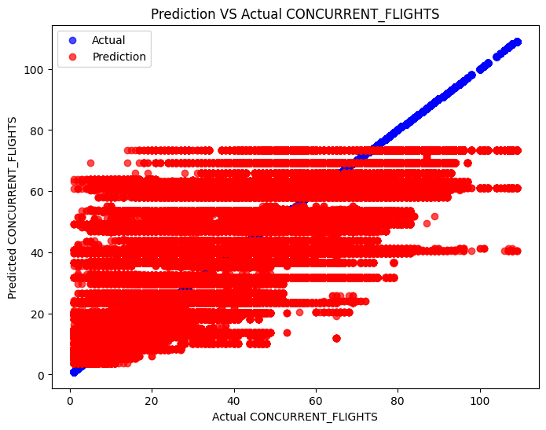
Figure 1. Prediction VS Actual Random Forest
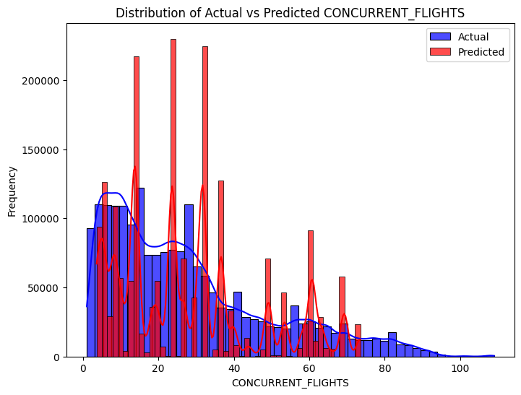
Figure 2. Distribution of Actual VS Predicted Random Forest
This result indicates that the default Random Forest model provided consistent performance across both training and testing sets. The parity between R² scores suggests minimal overfitting. The error values (MAE and RMSE) show the average and worst-case deviations in the predicted concurrent flight count
C. XGBoost Default Configuration
The default XGBoost model was trained using 100 estimators, a learning rate of 0.1, and maximum depth of 6. No tuning or staged optimization was performed at this point.

Table 8. XGBoost Accuracy Summary
Dataset | R² Score | MAE | RMSE
Training Set | 81.84% | 6.17 | 9.16
Testing Set | 81.86% | 6.17 | 9.16
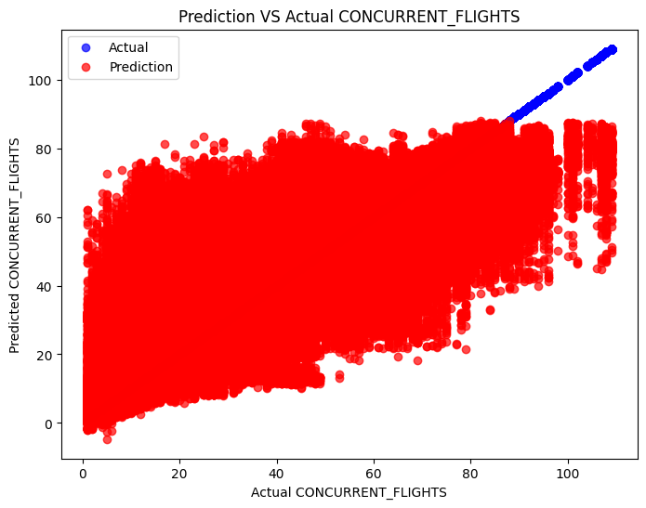Figure 3. Prediction VS Actual XGBoost
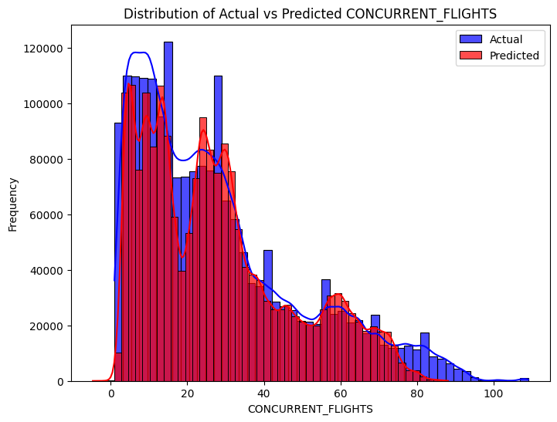
Figure 4. Distribution of Actual VS Predicted XGBoost
The XGBoost model performed better than the Random Forest baseline in terms of accuracy and error, even without hyperparameter tuning. The near-identical R² values on train and test sets also reflect stable generalization.
D. Random Forest Hyperparameter Tuned
Hyperparameter tuning for Random Forest was conducted using RandomizedSearchCV over a subset of 1.5 million samples. The search explored tree depth, number of estimators, leaf size, and feature splitting strategies. Two-fold cross-validation was applied.
Performance Summary:

Table 9. Random Forest RandomizedSearchCV Accuracy Summary
Dataset | R² Score | MAE | RMSE
Training Set | 88.19% | 5.29 | 8.21
Testing Set | 85.46% | 5.29 | 8.21
Selected Hyperparameters :
Table 10. Random Forest RandomizedSearchCV Selected Parameter
Parameter | Value
n_estimators | 500
max_depth | 30
min_samples_split | 10
min_samples_leaf | 4
max_features | sqrt
bootstrap | True
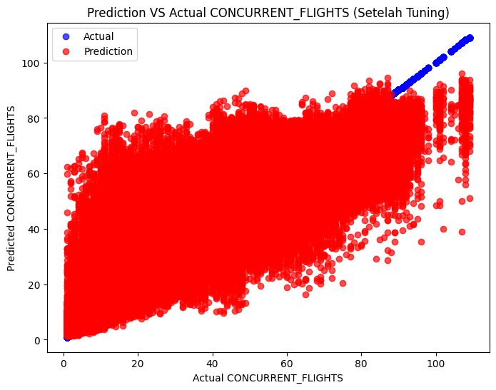Figure 5. Prediction VS Actual 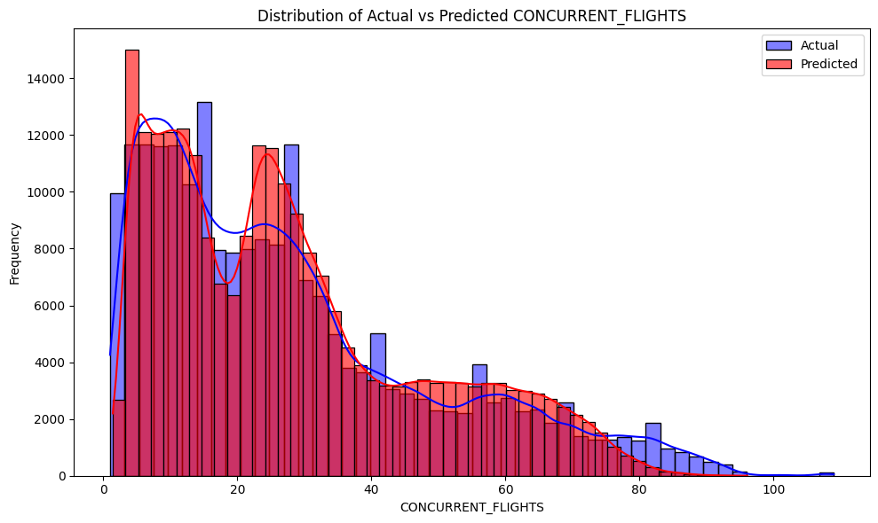
Figure 6. Distribution of Actual VS Predicted
The tuned model significantly outperformed the default configuration, demonstrating lower prediction error and improved fit without overfitting.
E. XGBoost Hyperparameter Tuned
XGBoost underwent a four-stage tuning process using GridSearchCV:
- Optimizing max_depth and min_child_weight
- Tuning subsample and colsample_bytree
- Adjusting learning_rate and n_estimators
- Finalizing with gamma
Each stage used two-fold cross-validation to reduce overfitting while maintaining runtime feasibility. The final model was retrained with the best combination.
Performance Summary:

Table 11. XGBoost GridSearchCV Accuracy Summary
Dataset | R² Score | MAE | RMSE
Training Set | 90.68% | 5.02 | 7.84
Testing Set | 86.73% | 5.02 | 7.84

Table 12. XGBoost GridSearchCV Tuning Stage Parameter
Tuning Stage | Parameter | Value
Step 1 | max_depth | 11
 | min_child_weight | 1
Step 2 | subsample | 0.9
 | colsample_bytree | 1.0
Step 3 | learning_rate | 0.05
 | n_estimators | 700
Step 4 | gamma | 0
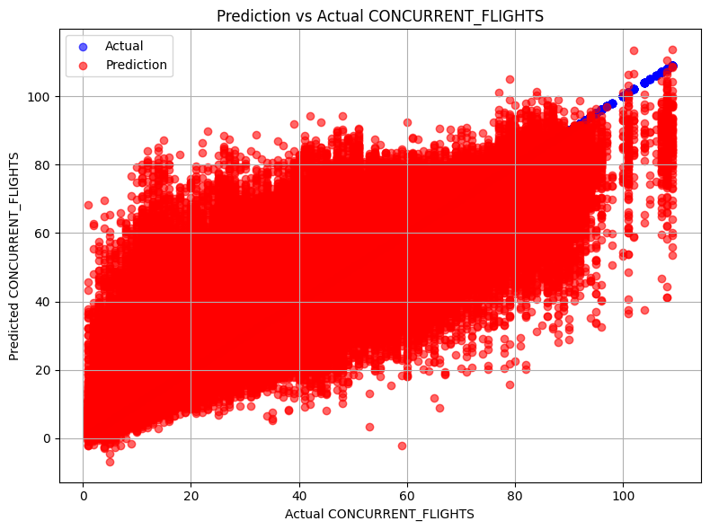
Figure 7. Prediction VS Actual
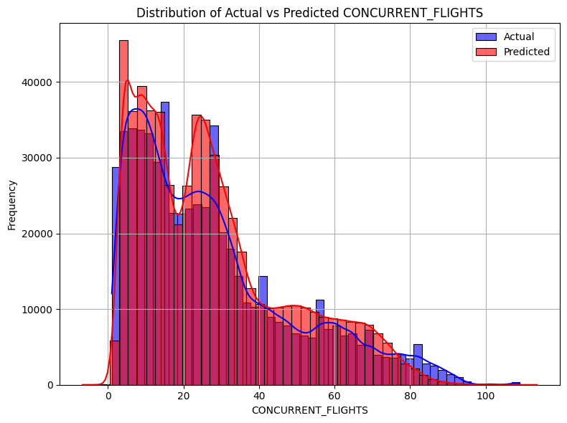Figure 8. Distribution of Actual VS Predicted
The final tuned model achieved the highest overall performance with the lowest prediction errors among all evaluated configurations.
E. Comparative Summary
The table below provides a consolidated comparison of the four model configurations evaluated in this study. These include the default and hyperparameter-tuned versions of both Random Forest and XGBoost, with evaluation conducted using three commonly used regression performance metrics: R² (coefficient of determination), Mean Absolute Error (MAE), and Root Mean Squared Error (RMSE).
Table 13. All Model Comparative Accuracy Summary
Model Configuration | R2 (Test) | MAE | RMSE
Random Forest (Default) | 76.74% | 7.09 | 10.38
XGBoost (Default) | 81.86% | 6.17 | 9.16
Random Forest (Tuned) | 85.46% | 5.29 | 8,21
XGBoost (Tuned) | 86.73% | 5.02 | 7.84
The comparative results in Table 13 clearly demonstrate that both algorithms Random Forest and XGBoost showed significant improvements in predictive performance after undergoing hyperparameter tuning. This result was consistently observed across all three evaluation metrics: R², MAE, and RMSE. The improvements highlight not only increased predictive power but also enhanced generalization and robustness. These findings reaffirm the crucial role that hyperparameter optimization plays in fine-tuning model behavior, especially for complex structured data tasks.
Among the default configurations, XGBoost outperformed Random Forest by a notable margin, achieving a higher R² (81.86% vs. 76.74%) and lower MAE and RMSE scores. This result aligns with the known strengths of gradient boosting algorithms, which typically outperform bagging-based models like Random Forest in accuracy, especially without prior tuning. After optimization, both models experienced substantial performance gains. Random Forest's tuned version reached an R² of 85.46%, with MAE and RMSE dropping to 5.29 and 8.21, respectively. However, XGBoost (Tuned) surpassed all other configurations, achieving the highest R² of 86.73%, alongside the lowest MAE (5.02) and RMSE (7.84).
The decrease in RMSE for the tuned XGBoost model indicates better handling of extreme errors and outliers, an important factor in real-world forecasting scenarios like concurrent flight prediction. Additionally, the relatively small gap between MAE and RMSE values suggests stable performance with low variance in prediction error. Overall, the comparative analysis confirms that while both algorithms are highly capable, XGBoost (Tuned) consistently delivers the most accurate and reliable predictions. These results reinforce the value of ensemble learning, particularly when combined with systematic tuning, and solidify XGBoost’s reputation as a top-tier algorithm for tabular regression problems.
F. Feature Importance Analysis
To gain a deeper understanding of the underlying decision-making logic of each model, feature importance analysis was conducted on all four trained configurations: default and tuned versions of both Random Forest and XGBoost. Feature importance refers to a metric that quantifies how much each input variable contributes to the model’s final prediction [31]. This type of interpretability analysis is particularly valuable in structured regression problems, like concurrent flight prediction, where feature interactions may be complex, non-linear, and often entangled due to redundancy or collinearity among operational and temporal variables [31].
Unlike classical linear regression models, which offer coefficient-based interpretations, tree-based ensemble models compute importance based on node impurity reductions (e.g., Gini index for classification, variance reduction for regression). In the case of Random Forest, the importance score is averaged over all trees, while XGBoost derives importance from gain, cover, or frequency, depending on the configuration. In this study, the default "gain" metric was used to assess which features contributed most significantly to reducing prediction error.
Across all model configurations, a consistently strong signal was observed from the variable AIRPORT_FLIGHTS_MONTH, which captures the average number of departures from a specific airport in a given month. This feature overwhelmingly dominated the importance scores, contributing over 50% to 60% of the total predictive weight in tuned models. This is not surprising, as concurrent flights are inherently linked to overall airport activity. Airports with high monthly departures naturally have a greater likelihood of multiple flights being scheduled within the same departure block.
What is particularly interesting is that this dominance persisted across both default and tuned configurations, suggesting that the signal from AIRPORT_FLIGHTS_MONTH is robust and universally recognized by both RF and XGBoost, regardless of hyperparameter changes. In the context of model interpretability, this affirms the face validity of the model, it makes intuitive sense that an airport's monthly traffic volume would be the most direct driver of concurrent departures.
- XGBoost (Tuned Configuration)
In the tuned XGBoost model (Figure 1), AIRPORT_FLIGHTS_MONTH contributed over 60% of the overall importance score, indicating that the model learned to rely heavily on this variable. Following this, categorical features derived from DEP_TIME_BLK, particularly DEP_TIME_Subuh and DEP_TIME_Malam, emerged as the second and third most important. This suggests that the model found patterns specific to early morning and late-night departures, where concurrent flight clustering may vary significantly from peak hours. Operational indicators such as AVG_MONTHLY_PASS_AIRLINE and staffing ratios like GROUND_SERV_PER_PASS also appeared, although with relatively low scores.
- Random Forest (Tuned Configuration)
The tuned Random Forest model (Figure 2) also showed a dominant reliance on AIRPORT_FLIGHTS_MONTH, accounting for more than 50% of total importance. However, unlike XGBoost, Random Forest assigned more weight to aggregated airline-airport metrics such as AIRLINE_AIRPORT_FLIGHTS_MONTH and AIRLINE_FLIGHTS_MONTH. These variables capture route-level demand, which likely supports the ensemble in estimating temporal congestion. Interestingly, features like SEGMENT_NUMBER and NUMBER_OF_SEATS—which were important in initial trials—had relatively diminished influence after tuning, possibly due to feature interaction effects.
- XGBoost (Default Configuration)
In the default configuration (Figure 3), XGBoost still prioritized AIRPORT_FLIGHTS_MONTH but with a slightly less skewed distribution compared to the tuned version. Several DEP_TIME categories such as Subuh, Malam, and Pagi ranked high, suggesting that the model already captured some temporal dynamics without tuning. However, the distribution of importance was more even, and no single feature dominated as heavily as in the tuned case. This reflects a less focused learning process, consistent with untuned models.\
- Random Forest (Default Configuration)
The default Random Forest model (Figure 4) produced the most skewed importance profile, where AIRPORT_FLIGHTS_MONTH alone accounted for nearly all the predictive weight. Other features such as AIRLINE_AIRPORT_FLIGHTS_MONTH and AIRLINE_FLIGHTS_MONTH contributed small but notable amounts, while the rest (including temperature and seat count) were effectively negligible. This suggests the model, in its default state, may have been under-regularized and overly dependent on a single dominant variable.
Tuned models, especially the XGBoost Regressor, exhibited greater diversity in feature importance distribution. In addition to AIRPORT_FLIGHTS_MONTH, several other variables started to emerge as significant, particularly:
- DEP_TIME_BLK_Subuh and DEP_TIME_BLK_Malam: indicating that early morning and late-night departures contribute differently to concurrency patterns.
- AVG_MONTHLY_PASS_AIRLINE: suggesting that the scale of airline operations, independent of the airport, affects flight clustering.
- GROUND_SERV_PER_PASS: reflecting operational staff ratios, potentially acting as a proxy for airport efficiency.
This broader distribution of feature importance in the tuned models implies that hyperparameter optimization does more than just improve numerical performance; it also improves the model's structural awareness, enabling it to capture a more nuanced picture of the operational environment.
To be clear, here is the comparative analysis between each model configuration :
Table 14. All Model Feature Importance Analysis
Model | Dominant Feature | Temporal Sensitivity | Operational Diversity
XGBoost (Tuned) | AIRPORT_FLIGHTS_MONTH | High (Subuh, Malam, Pagi) | Moderate
Random Forest (Tuned) | AIRPORT_FLIGHTS_MONTH | Moderate | High
XGBoost (Default) | AIRPORT_FLIGHTS_MONTH | High | Low-moderate
Random Forest (Default) | AIRPORT_FLIGHTS_MONTH | Low | Low
These patterns indicate that tuning not only improved predictive accuracy but also reshaped the model’s understanding of feature relevance, making it more balanced and context-aware. Temporal features (derived from departure time blocks) became more important in tuned versions, likely due to better model depth and optimized regularization. Operational metrics (like staff ratios or monthly averages) also gained weight after tuning, especially in the Random Forest variant.
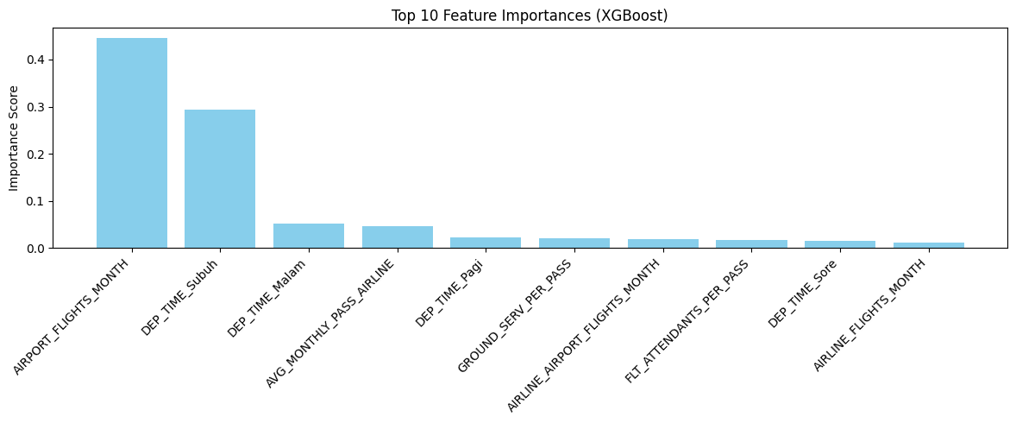
Figure 9. Top 10 Feature Importances (XGBoost Tuned)

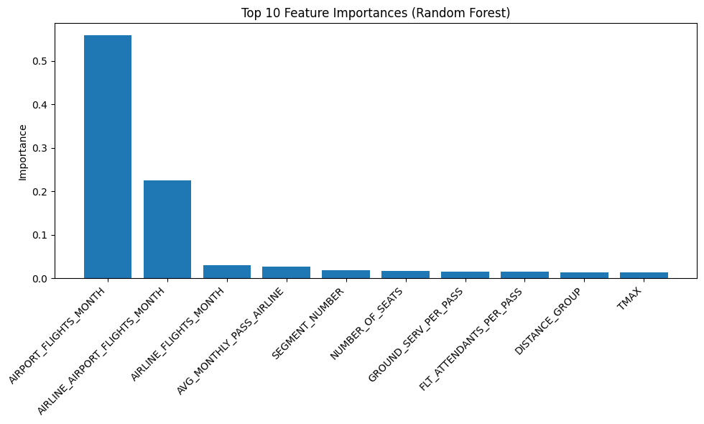
Figure 10. Top 10 Feature Importances (Random Forest Tuned)

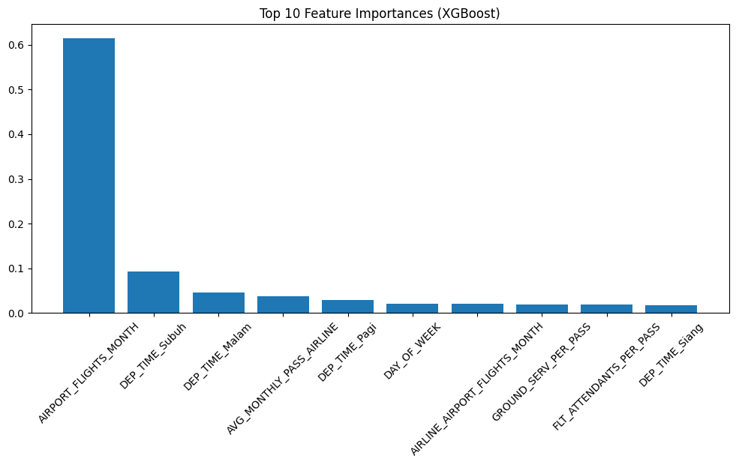
Figure 11. Top 10 Feature Importances (XGBoost Default)

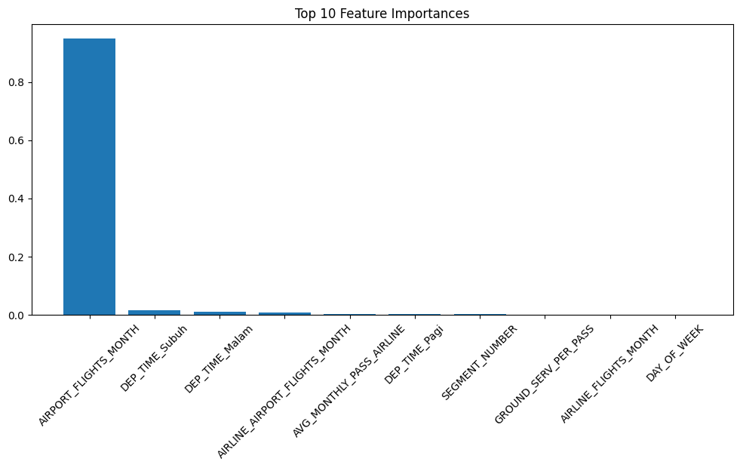
Figure 12. Top 10 Feature Importances (Random Forest Default)
F. Deployment Outcome
Following the model development and evaluation phase, the final step in this research was the deployment of the trained machine learning models into a user-friendly and interactive web platform. This deployment was crucial to transform the models from purely analytical tools into accessible systems that can be used by non-technical stakeholders such as airline planners, airport ground staff, or operational decision-makers in order to predict real-time prediction of concurrent flights. To achieve this, we use Streamlit, a Python-based web framework specifically designed for rapid development and deployment of machine learning applications. Streamlit provides a lightweight yet powerful environment to integrate .pkl model files, capture user input, generate predictions, and display results in real time all within a web browser interface.
In this study, we deployed two separate versions of the dashboard, each powered by a different machine learning model: Random Forest Regressor (Tuned) XGBoost Regressor (Tuned) Both models were previously trained and optimized through extensive hyperparameter tuning using RandomizedSearchCV (for Random Forest) and GridSearchCV (for XGBoost), and were saved in a .pkl format using Python’s pickle library.
These files contain not only the trained model weights but also the entire learned configuration, enabling seamless reuse without retraining. Each version of the dashboard shares the same front-end layout but differs in the backend model used. The interface was designed with the following features:
- Input Form
Allows users to manually enter feature values such as departure time block, aircraft age, number of seats, airline traffic data, and environmental variables.
- Prediction Output
Upon submitting the form, the dashboard returns a real-time prediction of the expected number of concurrent flights within the specified time block.
- Feature Importance Insights
The dashboard displays which features most heavily influenced the prediction, providing interpretability and transparency.
The screenshots below illustrate the deployed applications:
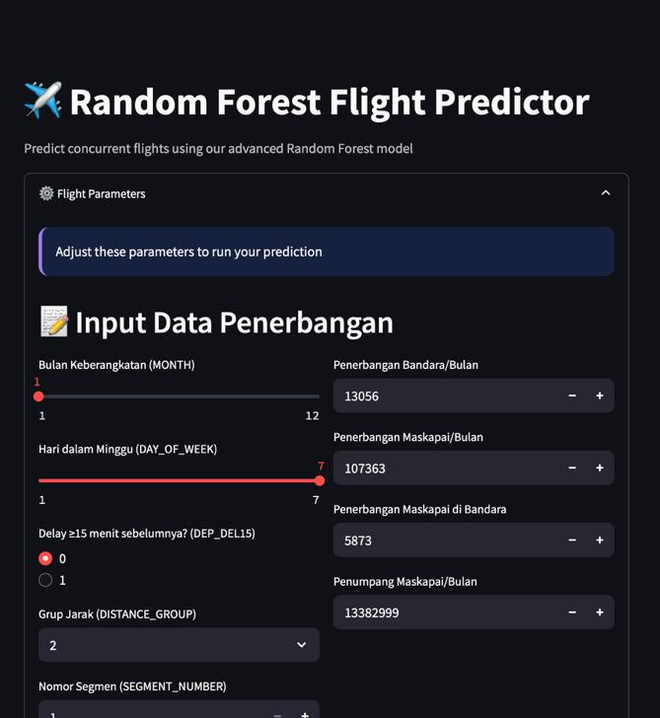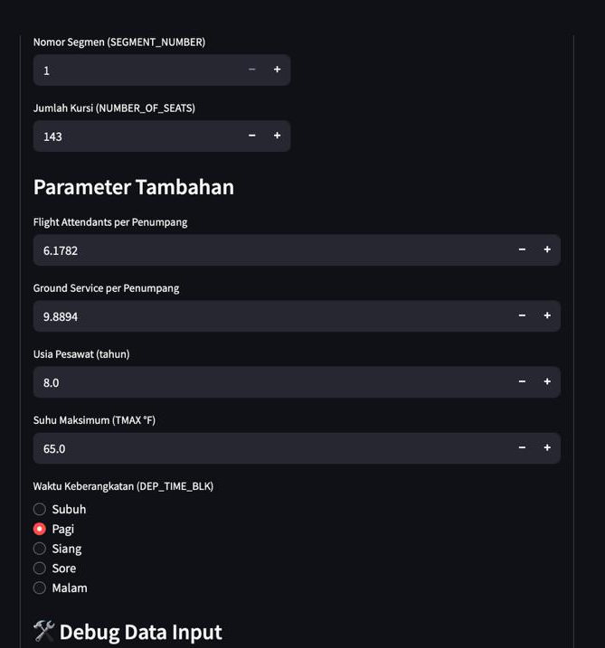
Figure 13. Random Forest Deployment Dashboard
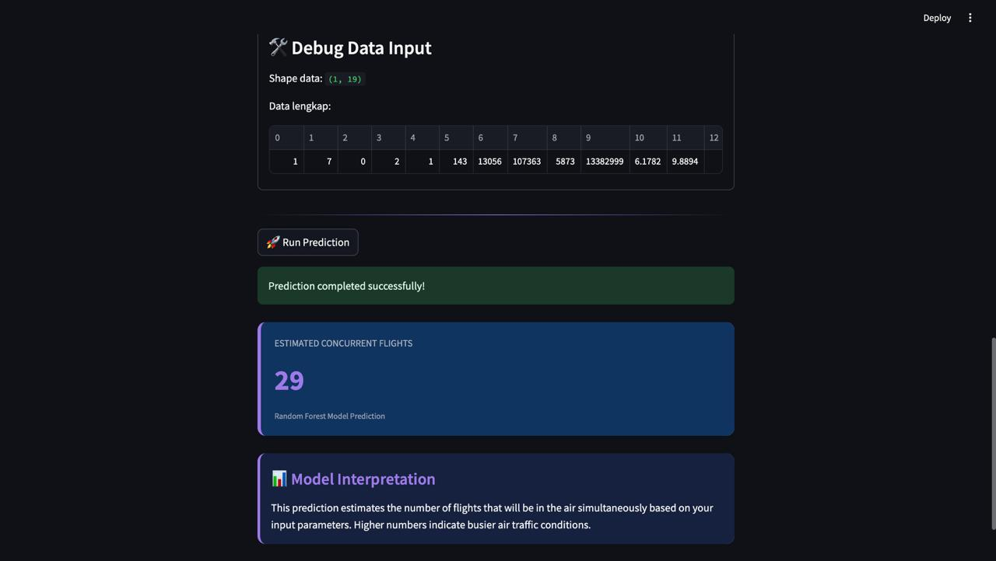
Figure 14. Random Forest Deployment Dashboard
This version uses the Random Forest model (.pkl file) optimized via randomized hyperparameter search. It generates real-time predictions based on user input.

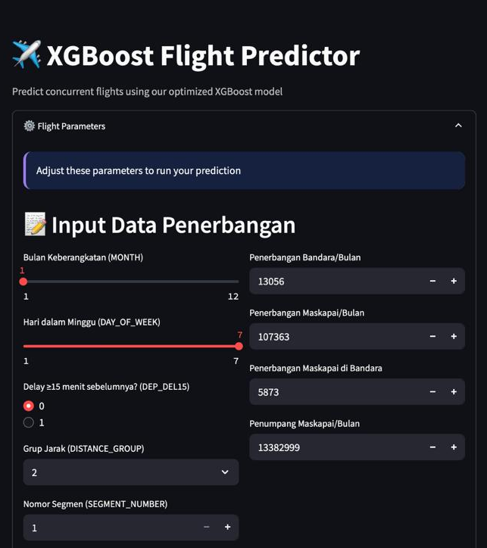
Figure 15. XGBoost Deployment Dashboard
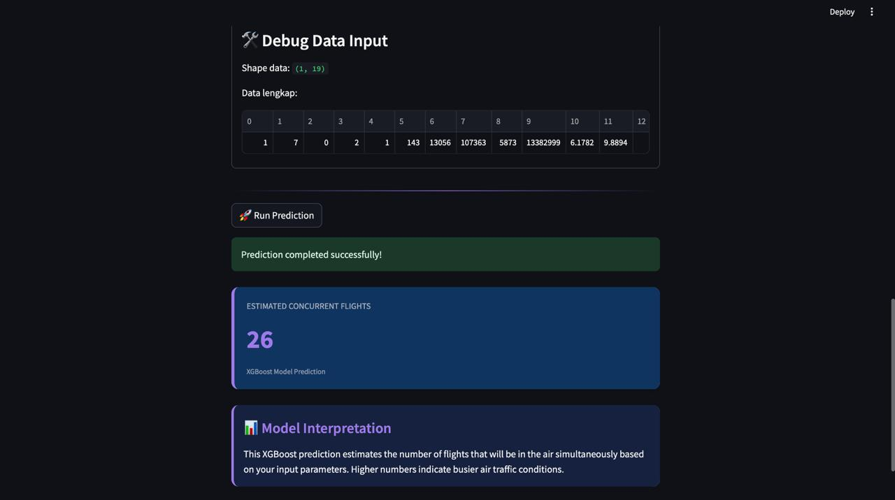
Figure 16. XGBoost Deployment Dashboard
This version employs the hyperparameter-optimized XGBoost model. The interface remains consistent, allowing for direct comparison of model outputs.
This dual-deployment setup enables comparative evaluation under identical input conditions, which is particularly useful for operational users seeking consistency in interface while testing alternative model behaviors.
The successful deployment of both models confirms the feasibility of integrating machine learning into real-world systems for air traffic management. It demonstrates how predictive models can be operationalized into decision support systems that are both reliable and accessible. Furthermore, deploying via Streamlit enables future scalability for example hosting on Streamlit Cloud, Heroku, or integration into larger airport management systems.
G. Power BI Based Result Visualization
To further support the interpretability and operational relevance of the developed prediction model, Power BI was employed as a post-modeling visualization tool.
While the Streamlit dashboard focuses on real-time prediction and interaction, Power BI serves as an analytical layer, allowing users to explore aggregated trends, identify patterns, and derive actionable insights from the full set of prediction results. This dual-layered approach helps bridge the gap between predictive modeling and strategic decision-making.
The dashboard was constructed using the complete prediction output from the tuned XGBoost model, incorporating various fields such as CONCURRENT_FLIGHTS, DEP_TIME_BLK, DAY_OF_WEEK, MONTH, NUMBER_OF_SEATS, and AVG_MONTHLY_PASS_AIRLINE. The dashboard included several types of visuals:
- KPI Summary Cards
- Total Concurrent Flights: 1.06 million predicted across all records.
- Total Seats Booked: 829 million, reflecting scale.
- Delayed Flight Percentage: ~19.01%, a key operational concern.
- Average Plane Age: 11.66 years, giving context to aircraft conditions.
- Average Max Temperature: 16.29°C, linking to environmental variables.
- Time-Series Trends
- Monthly Trend of Concurrent Flights: Shows a gradual increase through mid-year months, peaking around month 8–9, followed by a decline—possibly reflecting seasonal traffic cycles.
- Day-of-Week Trend: Concurrency appears higher mid-week, with a notable dip on day 5 (likely Friday), before rising again on weekends.
- Distribution Charts
- Histogram of CONCURRENT_FLIGHTS: Displays a right-skewed distribution where most departure blocks have fewer than 30 concurrent flights, with a long tail reaching above 100.
- Flight Delay Distribution (Pie): Confirms that the majority of flights (around 80%) did not experience >15 minute delays.
- Category Breakdown
- Pie Chart by DEP_TIME_BLK: Depicts flight proportions across time blocks, revealing that most flights cluster around morning to early afternoon.
- Pie Chart by DAY_OF_WEEK: Shows relatively balanced distribution, with slight peaks on days 2–4.
- Airport-Level Table
- Lists airports by total concurrent flights and booked seats, providing a granular breakdown for operational analysis.
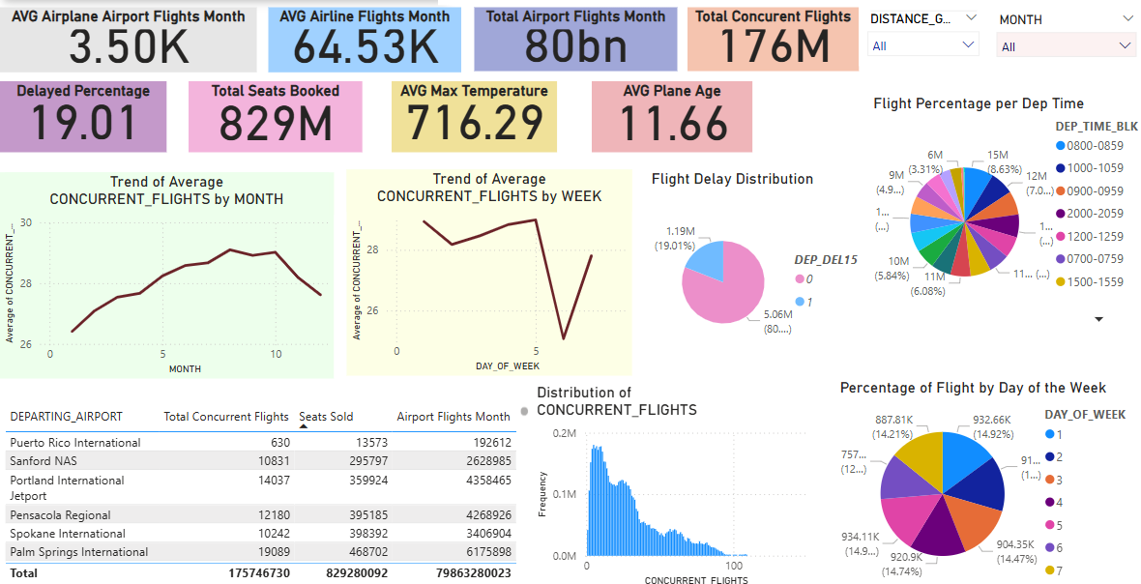
Figure 13. Data Exploratory Analysis (Power BI)

These visuals serve to:
- Validate model alignment with real-world trends
For instance, the trendlines of predicted concurrency by month and week match historical expectations, which indicate confidence in model behavior.
- Support operational diagnostic
The histogram of concurrency helps identify time of peak congestion blocks. Airports or schedules exceeding typical concurrency levels can be flagged for airport management.
- Enable stakeholder-friendly communication
The dashboard can allow airport managers and airline planners to consume the model’s output without needing to interpret raw numbers or code-based plots.
- Facilitate interactive filtering
Filters (e.g., for DISTANCE_GROUP, MONTH) support scenario exploration, enabling users to simulate how predicted concurrency changes under different conditions .based on different variable
Each visual was designed to provide both high-level overview and drill-down capability, enabling flexible scenario-based exploration.

H. Discussion
The results which have been discussed in this chapter illustrate the performance, behavior, and interpretability of two machine learning models trained with each configuration to predict the number of concurrent flight departures. This discussion analyzes those results so we can have a better understanding of each model’s strengths and limitations, in order to focus on both predictive quality and feature insights.
The XGBoost model with hyperparameter tuning configuration got the highest results in all metrics evaluation. This configuration yielded an R² score of 90.68% on training data and 86.73% on test data, it means that this configuration achieved the best balance between model fit and generalization. This performance was later validated by achieving the lowest error rates MAE of 5.02 and RMSE of 7.84 which indicated its durability in handling both typical and extreme values in the dataset.
By comparison, the Random Forest tuned model also achieved high performance on R² metric (88.19% train / 85.46% test), but slightly underperformed in terms of MAE and RMSE. While Random Forest benefited from tuning, it can be said that RF models are sensitive to dominant features such as AIRPORT_FLIGHTS_MONTH, so it may have limited flexibility in capturing more subtle patterns present in the data.
The default versions of both models performed reasonably well but it still has room for improvement. The default configurations of Random Forest, in particular, got the lowest predictive accuracy (R² around 76.7%) and higher error metrics, showing that its uninformed parameter settings restricted its learning capability. Interestingly, default XGBoost managed a relatively high test performance (R² around 81.9%), suggesting its base configuration already provides competitive results in structured regression problems.
A key finding across all configurations was the level of generalization gap. The default Random Forest had nearly identical R² values on train and test sets, which implies the model underfit the data, it lacked complexity to capture patterns effectively. On the other hand, XGBoost in default and tuned configuration showed only a tolerable difference between training and test scores, which indicates excellent generalization. The tuned Random Forest slightly overfit the training data (R² gap of around 2.7%), but the error margins remained within acceptable bounds. This shows us that while Random Forests are generally durable to overfitting, they are also heavily reliant on proper tuning of parameters like tree depth and minimum leaf size to optimize their learning curve.
One of the most astonishing results was the consistency of feature importance rankings across models. In all four configurations, the variable AIRPORT_FLIGHTS_MONTH dominated the feature space. This reinforces the hypothesis that monthly airport activity is the primary driver of concurrent flight volume. Moreover, only the tuned models, especially XGBoost show meaningful patterns from temporal and operational features. Variables like DEP_TIME_Subuh, DEP_TIME_Malam, and AVG_MONTHLY_PASS_AIRLINE appear on the top ranks, suggesting that the tuned models successfully captured behavioral nuances tied to scheduling blocks and airline capacity. Furthermore, the default Random Forest, by contrast, almost entirely ignored these subtleties, relying overwhelmingly on a single feature. This likely contributed to its relatively poor predictive performance and limited generalization.
From a deployment perspective, the XGBoost tuned model not only achieved the highest predictive accuracy but also gave the most interpretability, so it can further become a strong candidate for operational use. By identifying when and where flight clustering is likely, the model can be also integrated into airport capacity planning systems, delay mitigation strategies, or staff allocation tools. Additionally, the Streamlit dashboard deployment showed that the trained model could be effectively embedded into a lightweight user interface. The ability to upload datasets, generate real-time predictions, and review key contributing features provides value to airline operators and airport authorities without requiring machine learning expertise.
Beside these all strong results, there are still some limitations that must be acknowledged. First, the dataset relied more on historical aggregates and may not fully capture real-time dynamics such as emergency reroutes or weather anomalies. Second, the model is not yet included for seasonality patterns or weekday/weekend splits beyond the DAY_OF_WEEK variable. Finally, while the models were evaluated using common error metrics, future work should consider time-based validation to simulate real deployment conditions more accurately.
In addition to traditional evaluation metrics, the use of Power BI significantly enhanced the interpretability and operational relevance of the model outputs. By visualizing predicted concurrency trends across months, days of the week, and departure time blocks, stakeholders were able to assess whether the model’s predictions aligned with observed scheduling patterns. The distribution charts, KPI summaries, and interactive breakdowns provided by the dashboard allowed users to explore key performance indicators in a more intuitive and actionable format. This level of post-model transparency supports real-world applicability and connects the gap between technical outcomes and operational decision making.

4. CONCLUSION
This research aimed to develop a machine learning-based predictive model to estimate the number of concurrent flights departing from an airport within the same time block, using a comprehensive set of flight, airport, airline, and environmental features. Two ensemble-based regression algorithms such as Random Forest and XGBoost were implemented and evaluated under both default and optimized (tuned) configurations. The process encompassed data preprocessing, model training, hyperparameter tuning, evaluation, feature importance analysis, and web-based deployment.
The findings can be summarized as follows:
- Model Performance
The XGBoost model with hyperparameter tuning achieved the highest predictive performance with an R² score of 86.73% on test data, MAE of 5.02, and RMSE of 7.84. This indicates strong model generalization and reliable prediction accuracy. The tuned Random Forest model also demonstrated good performance (R²: 85.46%), but with slightly higher error rates.
- Impact of Tuning
Hyperparameter optimization significantly improved model performance for both algorithms. Default Random Forest, which achieved only 76.74% R², improved by nearly 9 percentage points after tuning. This validates the importance of tailored parameter selection in structured regression tasks.
- Feature Importance
Across all models, AIRPORT_FLIGHTS_MONTH emerged as the dominant predictor, reinforcing its central role in capturing departure density. However, only the tuned models effectively identified additional influential variables such as departure time categories (DEP_TIME_Subuh, DEP_TIME_Malam) and passenger volume metrics, which are critical for capturing temporal and operational nuances.
- Deployment Success
A lightweight Streamlit based dashboard was successfully implemented for real-time predictions. The interface allows non-technical users to upload flight data, receive predictions, and visualize top contributing features. This ensures the model’s accessibility for practical decision-making in airport scheduling and airline operations.
- Research Contribution
This work contributes to the aviation analytics domain by demonstrating how machine learning when combined with structured flight data can produce operationally useful predictions. It highlights the comparative behavior of two widely used tree-based models and bridges the gap between offline modeling and deployable tools.
While the results of this study are promising, several directions exist for further development and refinement:
- Temporal and Sequential Modeling
Future models could integrate temporal dynamics more explicitly by incorporating time-series architectures or recurrent neural networks (RNNs) to handle dependencies between consecutive time blocks or days.
- Expanded Feature Set
Additional data such as real-time weather reports, holiday/event indicators, air traffic control data, or runway availability could enhance the model's ability to capture transient spikes in concurrent flight activity.
- Model Ensemble or Stacking
Instead of relying on a single model, a hybrid ensemble (e.g., blending Random Forest, XGBoost, and LightGBM) could be explored to improve robustness and capture complementary feature patterns.
- Uncertainty Estimation
Integrating prediction intervals or Bayesian modeling techniques would allow the model to express confidence levels, aiding stakeholders in risk-based planning (e.g., assigning staff during high-congestion periods).
- Real-World Testing and Feedback Loop
Although the model has been deployed locally, further evaluation in a live operational environment with continuous feedback would help validate its practical utility. Integration with airport or airline control dashboards could also lead to iterative improvements based on user input.
- Explainability Enhancements
Tools such as SHAP (SHapley Additive exPlanations) or LIME could be added to the dashboard for more granular insights into why specific predictions were made especially for high-concurrency cases.
Furthermore, the integration of Power BI as a post-modeling visualization tool provided an effective bridge between machine learning outputs and stakeholder decision making. By visualizing such as time-based trends, categorical breakdowns, and interactive dashboards using Power BI can enable real-time interpretation and operational insight. This not only increased the models usability for airport and airline management but also demonstrated how predictive analytics can be connected into data exploratory analysis and give suggestions into data-driven decision in aviation environments.
The ability to predict concurrent flight departures accurately has direct influence for delay mitigation, runaway scheduling, crew assignment, and airport congestion control. Through the use of artificial intelligence machine learning and practical deployment tools, this research provides a complete, end to end solution in terms of turning historical flight data into operational intelligence.
The models which developed here, especially the tuned configuration of XGBoost regressor, give a strong foundation for further innovation in smart airport and airline systems. Further exploration and refinement of this framework can support more resilient and adaptive air traffic operations in the future.

REFERENCES

[1] Agrawal, M., Memarzadeh, M., Kalyanam, K. M., Mulholland, K., & Tan, R. (2024, January). Predicting Air Traffic Management Initiatives Using Supervised Learning. In AIAA SciTech Forum and Exposition. https://doi.org/10.2514/6.2024-0535
[2] Hatıpoğlu, I., & Tosun, Ö. (2024). Predictive Modeling of Flight Delays at an Airport Using Machine Learning Methods. Applied Sciences, 14(13), 5472.
[3] Lin, Y., Li, L., Ren, P., Wang, Y., & Szeto, W. Y. (2021). From aircraft tracking data to network delay model: A data-driven approach considering en-route congestion. Transportation Research Part C: Emerging Technologies, 131, 103329.
[4] Dai, M. (2024). A hybrid machine learning-based model for predicting flight delay through aviation big data. Scientific Reports, 14(1), 4603.
[5] Zachariah, R. A., Sharma, S., & Kumar, V. (2023). Systematic review of passenger demand forecasting in aviation industry. Multimedia tools and applications, 82(30), 46483-46519.
[6] Yang, C. H., Lee, B., Jou, P. H., Chung, Y. F., & Lin, Y. D. (2023). Analysis and forecasting of international airport traffic volume. Mathematics, 11(6), 1483.
[7] Su, J., Wu, H., Tsui, K. W. H., Fu, X., & Lei, Z. (2023). Aviation resilience during the COVID-19 pandemic: A case study of the European aviation market. Transportation Research Part A: Policy and Practice, 177, 103835. https://doi.org/10.1016/j.tra.2023.103835
[8] Wang, Y., Wong, C. W. H., Cheung, T. K. Y., & Wu, E. Y. (2021). How influential factors affect aviation networks: a Bayesian network analysis. Journal of Air Transport Management, 91, 101995.
[9] Javanmard, M. E., Tang, Y., & Martínez-Hernández, J. A. (2024). Forecasting air transportation demand and its impacts on energy consumption and emission. Applied Energy, 364, 123031.
[10] Aditya, V., Aswin, D. S., Dhaneesh, S. V., Chakravarthy, S., Kumar, B. S., & Venkadavarahan, M. (2024). A review on air traffic flow management optimization: trends, challenges, and future directions. Discover Sustainability, 5(1), 519. https://doi.org/10.1007/s43621-024-00781-7
[11] Zhu, Q., Chen, S., Guo, T., Lv, Y., & Du, W. (2024). A spatio-temporal approach with self-corrective causal inference for flight delay prediction. IEEE Transactions on Intelligent Transportation Systems. 10.1109/ACCESS.2024.3309001.
[12] Zámková, M., Rojík, S., Prokop, M., & Stolín, R. (2022). Factors affecting the international flight delays and their impact on airline operation and management and passenger compensations fees in air transport industry: Case study of a selected airlines in Europe. Sustainability, 14(22), 14763. https://doi.org/10.3390/su142214763
[13] Zhao, Z., Yuan, J., & Chen, L. (2024). Air traffic flow management delay prediction based on feature extraction and an optimization algorithm. Aerospace, 11(2), 168. https://www.mdpi.com/2226-4310/11/2/168MDPI
[14] Biswas, M. E., Sultana, T., Mandal, A. K., Golam Morshed, M., & Hossain, M. D. (2024). Spatio-Temporal Feature Engineering and Selection-Based Flight Arrival Delay Prediction Using Deep Feedforward Regression Network. Electronics, 13(24), 4910. 10.3390/electronics13244910.
[15] Xu, J., Zhang, J., Peng, Z., Bao, J., & Wang, B. (2023). Data-driven departure flight time prediction based on feature construction and ensemble learning. Journal of Aerospace InformationSystems, 20(12), 817–830.
[16] Bischl, B., Binder, M., Lang, M., Pielok, T., Richter, J., Coors, S., ... & Lindauer, M. (2021). Hyperparameter optimization: Foundations, algorithms, best practices and open challenges. arXiv. arXiv preprint arXiv:2107.05847. https://arxiv.org/abs/2107.05847
[17] Putatunda, S., & Rama, K. (2019, December). A modified bayesian optimization based hyper-parameter tuning approach for extreme gradient boosting. In 2019 Fifteenth International Conference on Information Processing (ICINPRO) (pp. 1-6). IEEE. 10.1109/ICInPro47689.2019.9092025
[18] Murugesan, R., Rekha, A. P., Nitish, N., & Balanathan, R. (2024). Forecasting airline passengers’ satisfaction based on sentiments and ratings: An application of VADER and machine learning techniques. Journal of Air Transport Management, 120, 102668. https://doi.org/10.1016/j.jairtraman.2024.102668
[19] Darmawan, H., Yuliana, M., & Samsono Hadi, M. Z. (2023). GRU and XGBoost Performance with Hyperparameter Tuning Using GridSearchCV and Bayesian Optimization on an IoT-Based Weather Prediction System. International Journal on Advanced Science, Engineering and Information Technology, 13(3), 851–862. https://doi.org/10.18517/ijaseit.13.3.18377
[20] Kavzoglu, T., & Teke, A. (2022). Advanced hyperparameter optimization for improved spatial prediction of shallow landslides using extreme gradient boosting (XGBoost). Bulletin of Engineering Geology and the Environment, 81(5), 201. doi: 10.1007/s10064-022-02708-w.
[21] Kaewunruen, S., Sresakoolchai, J., & Xiang, Y. (2021). Identification of Weather Influences on Flight Punctuality Using Machine Learning Approach. Climate, 9(8), 127. https://doi.org/10.3390/cli9080127
[22] Ajayi, J., Xu, Y., Li, L., & Wang, K. (2024). Enhancing Flight Delay Predictions Using Network Centrality Measures. Information, 15(9), 559. https://doi.org/10.3390/info15090559
[23] Kiliç, K., & Sallan, J. M. (2023). Study of delay prediction in the US airport network. Aerospace, 10(4), 342. https://www.mdpi.com/2226-4310/10/4/342
[24] Ajayi, J., Xu, Y., Li, L., & Wang, K. (2024). Enhancing Flight Delay Predictions Using Network Centrality Measures. Information, 15(9), 559. https://www.mdpi.com/2078-2489/15/9/559
[25] Afrane, M. D., Xu, Y., Li, L., & Wang, K. (2025, March). Flight Delay Prediction Using Random Forest with Enhanced Feature Engineering. In SoutheastCon 2025 (pp. 1055-1056). IEEE. https://doi.org/10.1109/southeastcon56624.2025.10971443
[26] Demir, G., Moslem, S., & Duleba, S. (2024). Artificial Intelligence in Aviation Safety: Systematic Review and Biometric Analysis. International Journal of Computational Intelligence Systems, 17(1), 1-30. 10.1007/s44196-024-00671-w.
[27] Teja, M. D., & Rayalu, G. M. (2025). Optimizing heart disease diagnosis with advanced machine learning models: a comparison of predictive performance. BMC Cardiovascular Disorders, 25(1), 212. 10.1186/s12872-025-04627-6
[28] Bhat, S., & Szczuko, P. (2025). Impact of canny edge detection preprocessing on performance of machine learning models for Parkinson’s disease classification. Scientific Reports, 15(1), 1-38.
[29] Nishat, M. H., Khan, M. H. R. B., Ahmed, T., Hossain, S. N., Ahsan, A., El-Sergany, M. M., ... & Alresheedi, M. T. (2025). Comparative analysis of machine learning models for predicting water quality index in Dhaka’s rivers of Bangladesh. Environmental Sciences Europe, 37(1), 31.
[30] Zhou, L., Zhu, Q., Chen, Q., Wang, P., & Huang, H. (2025). Predicting hospital outpatient volume using XGBoost: a machine learning approach. Scientific Reports, 15(1), 1-13.
[31] Yang, L., Liu, S., Sun, H., Che, C., & Tang, L. (2025). Comparison of six machine learning models suitable for use in medicine: support for osteoporosis screening and initial diagnosis. Chinese Journal of Tissue Engineering Research, 29(35), 7499.
[32] Cao, X., Ma, J., He, X., Liu, Y., Yang, Y., Wang, Y., & Zhang, C. (2025). Unlocking the link: predicting cardiovascular disease risk with a focus on airflow obstruction using machine learning. BMC Medical Informatics and Decision Making, 25(1), 50.

